ECSE-200 Electric Circuits 1 - Quiz #9 (Mar. 22, 2019)

**LAST NAME** ______________________________________________ **MCGILL ID#** __________________

**FIRST NAME­­­­­­­­­**________________________________**SIGNATURE**_________________________________

* ***Only Faculty standard calculator accepted***
* ***No cellphone allowed***
* ***Show all your work***
* ***Clearly indicate your final answer with the SI unit and multiplier***
* ***You have 45 minutes to complete this quiz***

**__________________________________________________________________________________________**

**Question 1:** Consider the 20 μH inductor (L = 20 μH) shown below along with the diagram illustrating the current *i(t)* flowing through the inductor as a function of time *t*. Answer the following questions.

1. What is the voltage *v* at time *t =* 2 μs? [1 pt]
2. Plot the voltage *v(t)* versus time *t* indicating the voltage values? [2 pt]
3. What is the instantaneous power at time *t* = 10 μs? [1 pt]
4. What is the energy stored as electric potential energy *U(t)* in the inductor at time *t* = 4 μs? [1 pt]

Extra Working Space

**Question 2:** The switch in the switched circuit shown below has been opened for a long time. In other words, the circuit is in steady state for $t < 0 s$. The switch closes making the connection at time $t = 0 s$. Answer the following questions.

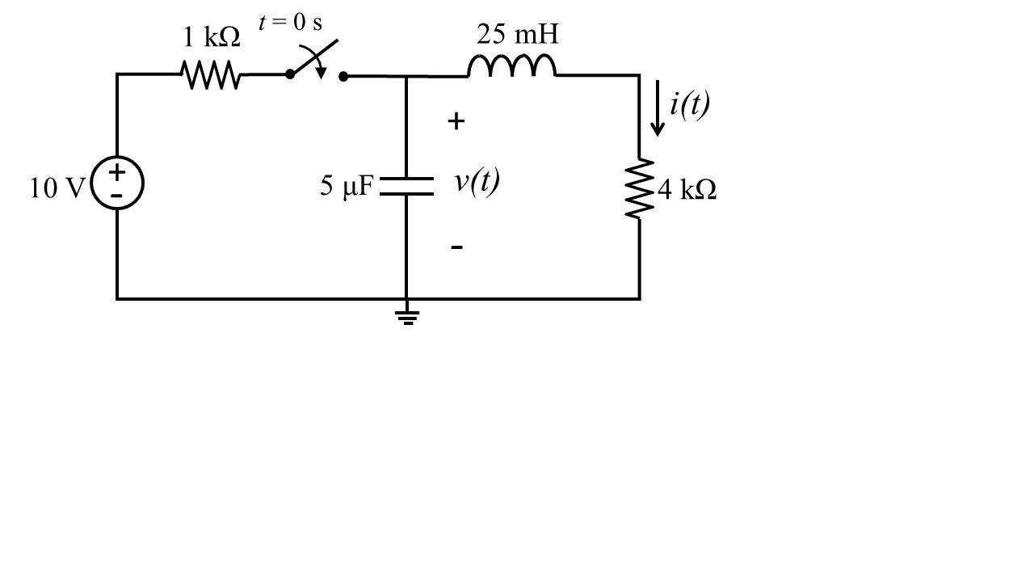

1. Draw the circuit in steady state for time $t < 0 s$ and find the values for the voltage $v(t)$ and the current $i(t)$ for $t < 0 s$. [2 pt]
2. Find the values for the voltage $v(t)$ and the current $i(t)$ immediately after the switch closes ($v(0^{+})$ and $i(0^{+})$)? [2 pt]
3. Draw the circuit in steady state for time $t → ∞$ and find the voltage $v(t)$ and the current $i(t)$. [2 pt]

Extra Working Space